LETS REVIEW TRIGONOMETRY  
  
  
  
  
  


Jonathan Quang Period 1

"Success is your only option, failure's not"

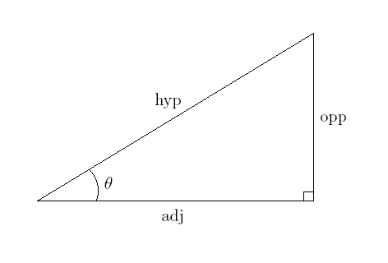Right Triangle Trigonometry

θ represents the angle you are currently looking at, and angle measures in general  
In a right triangle, the three trigonometric ratios you may remember from last year are sine, cosine, and tangent.  
They are abbreviated as sin, cos, and tan.  
sinθ = $\frac{opposite}{hypotenuse}$  
cos θ = $\frac{adjacent}{hypotenuse}$

tan θ = $\frac{opposite}{adjacent}$  
You can remember this with the mnemonic SOH CAH TOA

It may also help to remember Pythagoras's theorem $a^{2}+b^{2}=c^{2}$ where a and b are the lengths of the legs of the right triangle and c which is the length of the hypotenuse.

The Unit Circle

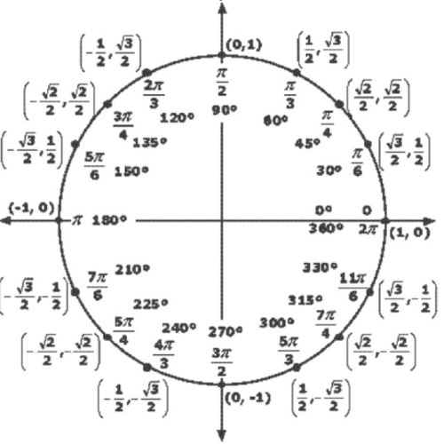  
A unit circle has its center at the origin of a graph with a radius of 1.

Using an x and y coordinate, you can draw a right triangle whose corner lies on the circle. The right triangle will always have a hypotenuse of 1, meaning that:  
**The x-coordinate is cos** **θ**  
and the **y-coordinate is sin θ**

Trigonometric Functions of Special Angles

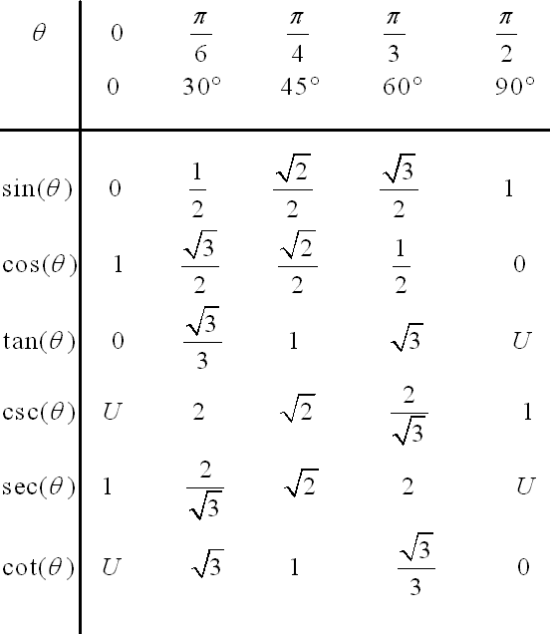

U stands for undefined, as in the ratio has a 0 in the denominator.

These are the values for certain degree measures you should know. However, these cover ratio values for degree measures in the first quadrant of the unit circle.  
Remember this diagram on the previous page?  
  
You will notice that **a**ll of the three trig ratio values in the first quadrant are positive, all **s**ine values in the second quadrant are positive while the rest are negative, all **t**angent values are positive in the third quadrant while the rest are negative, and all **c**osine values in the fourth quadrant are positive. If you take all the bolded letters that tell what values are positive, it spells out **ASTC**. A good way to remember this is the mnemonic: "**A ST**i**C**k."

To find the ratio from any of the special angle measures from anywhere on the unit circle, you must think about the reference angle to the x-axis. That is the angle you match to the chart two pages back. Then you determine the sign of the ratio from which quadrant the angle lies in. For example, cos150 degrees. Cos150 degrees makes a 30 degree angle with the x-axis. This means the ratio is $\frac{\sqrt{3}}{2}$. Since this angle lies in the second quadrant, we know that only sine values are positive. This means that our final answer is - $\frac{\sqrt{3}}{2}$.

Reciprocal Trigonometric Functions

Reciprocal trigonometric functions are secant, cosecant, and cotangent. They are, as the name suggests, reciprocals of trig ratios. Look at the following chart:

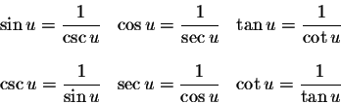

Cosecant is the reciprocal of sine  
Secant is the reciprocal of cosine  
Cotangent is the reciprocal of tangent

Radian Measure

A radian is a unit of measure of an angle (similar to degrees) where one radian as the central angle measure inside a circle corresponds to an arc length equal to the radius of the circle.  
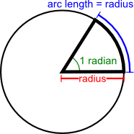

You will find that 1 radian = $\frac{π}{180 }$* degrees  
and degrees = $\frac{180}{π}$* degrees

Co-functions

Co-functions are trigonometric functions where one trig function of θ is equal to another trig function of θ's complement.

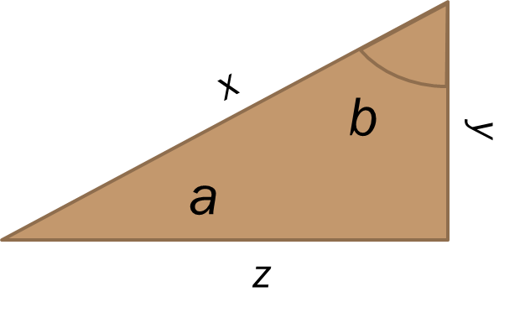

In this diagram, angle a and b are complements of each other.

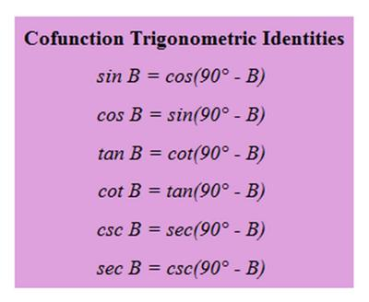  
Sin-Cos, Tan-Cot, Csc-Sec are the cofunction "pairs."

Trigonometric Identities

Pythagorean Identities: These are obtained by taking Pythagoras's theorem and substituting variables with things from the unit circle. Through this, we obtain the following  
sin2 θ + cos2 θ = 1  
By dividing both sides by sin2 θ or cos2 θ, we obtain  
1 + cot2 θ = csc2 θ  
tan2 θ + 1 = sec2 θ

Quotient Identities:  
tan θ = $\frac{sinθ}{cosθ}$ cot θ = $\frac{cosθ}{sinθ}$

Reciprocal Identities:  
sec θ = 1/cos θ  
csc θ = 1/sin θ  
cot θ = 1/tan θ

Graphing Trigonometric Functions

Generally trig functions are graphed with the y-axis representing the ratio value and the x-axis representing the angle measure in radians.  
Trig functions are periodic functions, meaning that the function is such that there exists a real number where p > 0 that f(x + p) = f(x) for all x∈domain.  
Period: The smallest value of p  
Amplitude: (m-n)/2 where and n are the maximum and minimum of the graphs.  
Frequency: The number of times the graph of the parent function appears in the period  
Phase shift: The horizontal shift of the parent function. Since the function is periodic, there are multiple horizontal shifts, however you generally write the horizontal shift with the smallest absolute values  
Vertical Translations: The vertical shift of a function compared to its parent function.

Sine Parent Function Graph:  
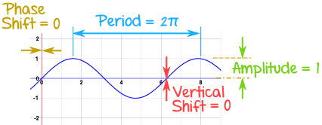 Domain: (-∞,∞)  
Range:[-1,1]  
Amplitude: 1  
Period: 2 π  
Frequency: 1  
Symmetry: Odd function  
y-intercept: 0  
x-intercept: {x: n∈Z, x=n π}  
  
Cosine Graph:  
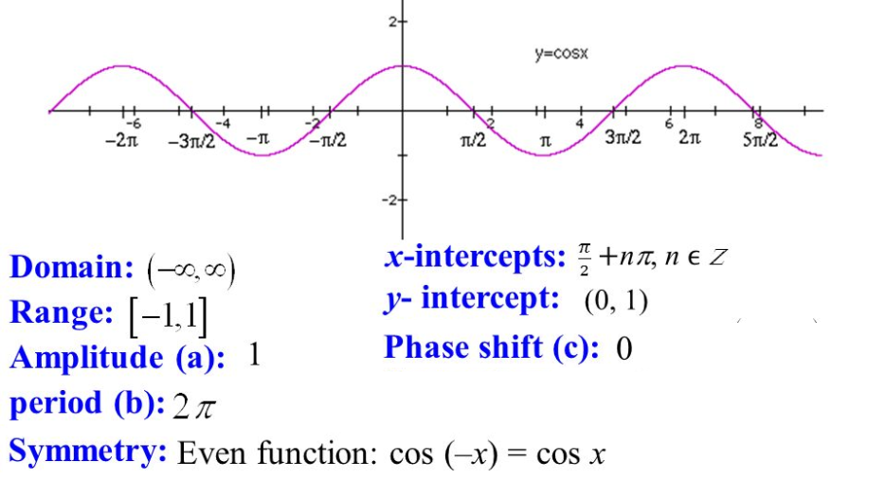

You will notice that:  
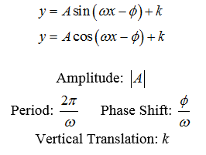

Tangent Function:  
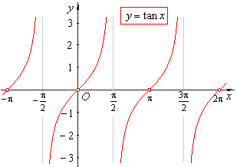  
You will notice that the tangent function intercepts the x-axis every integer multiple of pi and there are vertical asymptotes at every odd number * (pi/2) interval  
Domain: All real numbers except where vertical asymptotes occur  
Range: All real numbers  
Period: π  
Amplitude: Does not exist

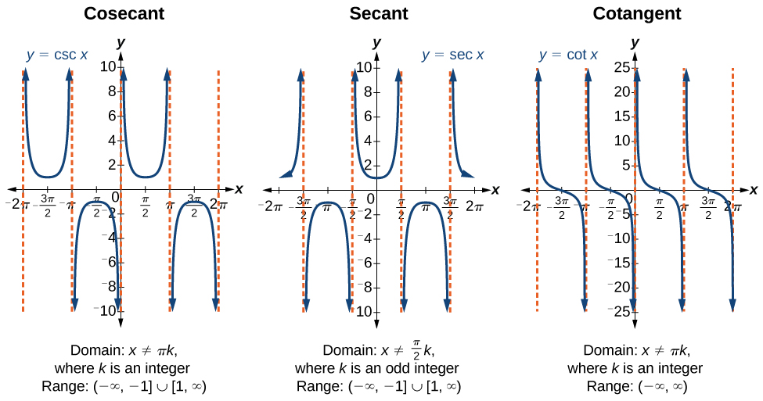Graphs of reciprocal Trigonometric Functions:

Period: π  
Amplitude: Does not exist

Graphs of Inverse Functions  
Keep in mind that for a relation to be called a function, it must pass the vertical line test. Sometimes the inverse of a trig function is referred is called arc + <name of trig function>

|  |  |  |
| --- | --- | --- |
| Function | Domain | Range |
| y=arcsinx | -1 ≤x ≤ 1 | -90 to 90 degrees |
| y=arcosx | -1 ≤ x ≤ 1 | 0 to 180 degrees |
| y=arctanx | All real numbers | -90 to 90 degrees |

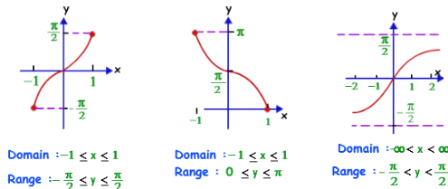Arcsin Arccos arctan

Solving trigonometric equations

It helps to know by memory all trigonometric identities when solving trigonometric equations.   
1) Move all terms with variables to one side of the equation  
2) Apply your knowledge of trig identities to convert all trig functions into a single function  
3) Simplify the trig side of the equation into a single term  
4)Solve, but make sure you account for the given range in the directions, typically from 0 degrees to 360 degrees. There may be multiple solutions and extraneous solutions

Here's an example:  
4 sin θ = -4 + 3cos2 θ  
4 sin θ- 3cos2 θ = -4   
4sin θ - 3(1-sin2 θ)=-4  
4sin θ-3+3 sin2 θ=-4  
3 sin2 θ + 4 sin θ -3 = -4  
3 sin2 θ + 4 sin θ + 1 = 0  
sin θ = {-1/3 , -1}  
For sin θ to be negative, it must exist in quadrant 3 and 4 in the case of sin θ = -1/3. The reference angle made by sin θ in reference to the x-axis can be found by using arcsin on the calculator. The result is 19.471... degrees. The value of θ with a reference angle of 19.471... degrees in quadrant 3 and 4 are about 199 and 341 degrees. Both these answers are valid. Now for sin θ = -1, we know that it is 270 degrees. Thus, θ={199,270,341}

Sum and Difference Formulas

cos(a+b)=cos(a)cos(b) - sin(a)sin(b)  
cos(a-b)=cos(a)cos(b) + sin(a)sin(b)  
sin(a+b)=sin(a)cos(b) + cos(a)sin(b)  
sin(a-b)=sin(a)cos(b)-cos(a)sin(b)  
tan(a+b)= $\frac{\tan\left(a\right)+ tan⁡(b)}{1-\tan\left(a\right)tan⁡(b)}$ 
tan(a-b) = $\frac{\tan\left(a\right)- tan⁡(b)}{1+\tan\left(a\right)tan⁡(b)}$

Double Angle and Half Angle Formulas

cos(2a)=cos2(a) - sin2(a)   
other variations are: 2cos2(a) -1 and 1-2sin2(a)

sin(2a)=2sin(a)cos(a)  
tan(2a) = $\frac{2tan⁡(a)}{1-\tan^{2}(a)}$

cos(a/2) = $±\sqrt{\frac{1+cos⁡(a)}{2}}$  
sin(a/2) = $±\sqrt{\frac{1-cos⁡(a)}{2}}$  
tan(a/2) = $±\sqrt{\frac{1-cos⁡(a)}{1+cos⁡(a)}}$

Area of a Triangle

You should remember this from elementary school:  
Area = (1/2) * base * height

Occasionally, you may be missing a height or a base, but have an angle measure. Using a right triangle and some trig, you can find the missing height or base. You may need to make a right triangle that splits one side of a triangle into two line segments. Set one segment to x and the other segment as (side length - x) to solve.

You may also remember Heron's formula from geometry:  
s= semiperimeter  
a,b,c are the lengths of a triangle  
s = (a+b+c)/2 $$A=\sqrt{s\left(s-a\right)\left(s-b\right)(s-c)}$$

A more obscure way of finding the area of a triangle is if you are given a circle inscribed in a triangle.  
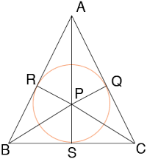  
The area of the triangle = (radius of the circle)(semiperimeter of the triangle).

Law of Sines and Cosines

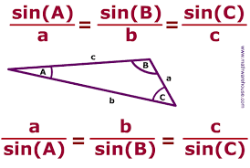  
Given such a triangle, the law of sines is as follows: $\frac{sinA}{a}$ 
= $\frac{sinB}{b}$ = $\frac{sinC}{c}$

When using the law of sines to solve for an angle measure, remember the following:

bsinA > a no solution  
bsinA < a 2 solutions  
bsinA = a 1 solution

A is the angle you solved for  
a is the side opposite the angle you solved for  
b is the other side you used in the law of sines

The law of cosines is this following formula  
c2=a2 + b2 +2abcos(C)  
where a and b are the sides surrounding angle C and c is the side opposite angle C.

Disclaimer: graphics used in this handbook were not made by me. Credit goes to their respective owners